Chapter 17, Problem 67.

Calculate the Fourier coefficients of the signal in Fig. 17.58 using PSpice.

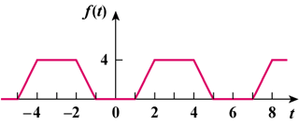

Figure 17.58
For Prob. 17.67.

